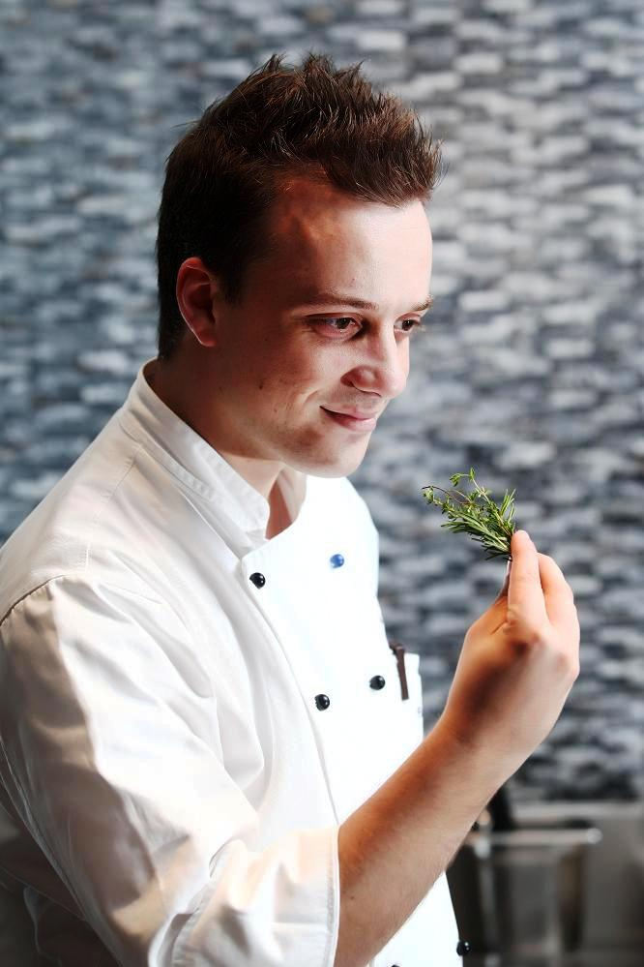
Name
Fabio Polidori
Email
fabio.polidori@renaissancehotels.com
fpoli569@hotmail.com
Skype
fabe_vie

Fabio Polidori

PROFILE:
An enthusiastic, motivated, competent Chef with hotel companies, outlet restaurant and catering experiences.
With passion for food, extensive knowledge in food preparation and presentation techniques

With good communication skills, I have a cheerful personality which is helpful in handling people of different backgrounds and cultures

As a Chef, it is my aim is to continually improve my chosen profession and work for a company that nourishes that aim

WORKING
EXPERIENCE:

November 2009 to date

Executive Sous chef/Italian Chef

Renaissance Bangkok Ratchaprasong
Bangkok, Thailand

Company Profile:
Renaissance Bangkok Ratchaprasong 5star Hotel located close by finest shopping and business district.
A unique 200-meter-long landscaped driveway with water features provides an unforgettable arrival experience.
Inside, this hotel's accommodations feature artfully balanced guest rooms with oversized windows, plush bedding and state-of-the-art amenities. In addition, guests will find a world-class spa, fitness center, business center and eclectic dining options - all just steps from their door. For those planning a business meeting or social celebration, hotel also includes 19,999 sq ft of sophisticated event space and on-site catering services

Restaurants Profile:
Flavors-International: Serving breakfast lunch and dinner, this stylish 160-seat restaurant is located on the hotel's second floor. The interior of the restaurant is broken into different zones, with open-kitchen areas open from 6 a.m. to 11 p.m.

La Tavola-Italian: This Downtown restaurant in Bangkok features a fresh Italian cuisine and a stylish wine bar.

Fei Ya-Chinese: Experience Bangkok fine dining as never before. Indulge in modern, Chinese cuisine, including roasted duck and northern specialties.

Responsibilities:
• Responsible for ordering, menu planning, recipe creation, cost control and organizing kitchen operation for special function and outside catering.
• Implemented and set policies and procedures of high culinary standard in accordance to Marriott standards.
• Manages daily kitchen operation Italian kitchen, main kitchen, banquet and In Room dining.
• Implementing food hygiene procedures through staff training and internal audits.
• Conducts food tasting before implementation of promotions
• Checks and controls food deliveries to ensure quality products received and food storing.

July 2008- December 2008
Chef Consultant-Pre Opening Team
All Star Sport Bar & Grill
Beijing– P. R. China

Company Profile:
All-Star Sports Bar & Grill, the most innovative & high-tech sports bar venue, with 65 Plasma screens, opened the door on August 2008.
Serving classic American dishes, traditional Mexican and Mediterranean cuisine including freshly baked bread and pizzas.

Responsibilities:
• Manages the daily operation of the restaurant.
• Responsible for ordering, menu planning, recipe, cost control.
• Implementing food hygiene procedures through staff training.

May 2006- July 2008
Head Chef – Sezzam & 24/7 Restaurant

Kempinski Hotel Mall of the Emirates
Dubai, United Arab Emirates

Company Profile:
Kempinski Hotel Mall of the Emirates is attached to a giant shopping mall and in the same complex that houses the world famous indoor ski slope, Ski Dubai.
24 Seven – a casual dining all day restaurant that specializes in traditional Italian cuisine with a modern twist.
Sezzam – Eat Dubai, a 1000-seat restaurant is a completely new concept including of three interactive open-kitchens.
- Steam: specializes in Asian style cooking
- Bake: offering predominantly Mediterranean fare, pizza, handmade pasta, a range of international food from wood fired ovens
- Flame: This boasts charcoal grill as well as several Tandoori ovens, rotisserie and a spit roast

Responsibilities:
• Responsible for ordering, menu planning, recipe creation, cost control and organizing kitchen operation.
• Implemented and set policies and procedures of high culinary standard in accordance to Kempinski standards.
• Manages daily 20 staff in Sezzam Bake Section and overseas 90 kitchen staff in the absence of the Executive Chef.
• Implementing food hygiene procedures through staff training and internal audits.
• Conducts food tasting before implementation of promotions
• Checks and controls food deliveries to ensure quality products received and food storing.

Awards & Recognitions:
• Together with our Executive Chef, formulated 159 dishes to be exclusively served in all inbound and outbound flights of Lufthansa German Airlines.
• Sezzam – Eat Dubai, awarded as the Best Family Restaurant 2006 by Time Out Dubai.
• Recognitions from Emirates Culinary Guild through the magazine by publishing recipes for the guilds' magazine and newspaper.
• Bronze medal winner for Presentation of Finger Food & Tapas during the Saloon Culinary Competition 2007.
• Silver medal winner for 5 Course Gourmet Dinner Menu during the Saloon Culinary Competition 2008

January 2005- April 2006
Head Chef
Felix Restaurant
Kempinski Hotel Nikopolis Thessaloniki, Greece

Company Profile:
The Kempinski Hotel Nikopolis Thessaloniki, it is a boutique city-resort that captures the contemporary spirit, attracting the ones who seek something fresh and original.
Felix brought the true art of Italian cooking to Thessaloniki, featuring a menu that reflects the soul Italy’s appetite.

Responsibilities:
• Developed menus and promotions.
• Trained kitchen staff of the restaurant on understanding of Italian Cuisine and Regional Specialities.
• Responsible for ordering, menu and recipe costing.
• Maintained and applied Food Hygiene Regulations HACCP.

January 2004- January 2005
Chef de Cuisine
Rossano's Restaurant
Brisbane, Australia

Company Profile:
A contemporary 80-seat Italian restaurant Serving original Tuscany recipes with four degustation and a la carte menus,

Responsibilities:
• Managed the kitchen operation of the restaurant with 4 chefs.
• Planned promotional and specially requested set menus.
• Maintained and applied food hygiene regulations HACCP
• In charge of supplies, production and quality check

Awards & Recognitions:
• Winning award as Best Italian Restaurant in Brisbane, 2004.

OTHER WORK
EXPERIENCES:
January 2004- January 2003
Chef de Partie
Cavallino Ferrari Restaurant
Modena, Italy

April 2003- September 2003
Chef de Partie (Tournant)
Summer Resort Gabicce Mare***
Rimini, Italy

January 2002- November 2002
Demi Chef de Partie
Ristorante Symposium 4 stagioni
Cartoceto, Italy

April 2001- October 2001
Demi Chef de Partie
Hotel Restaurant Blu Marina***
Fano, Italy

March 2000 - November 2000

Pastry & Bakery Junior Assistant
Pasticceria Nolfi
Fano, Italy

April 1999- October 1999
Commis de Cuisine 1
Hotel Giulietta***
Riccione, Italy

April 1998- October 1998

Commis de Cuisine 2
Hotel Cristallo***
Riccione, Italy

January 1995 to January 1998

Apprentice
Restaurant Il Giardino
Fossombrone, Italy

TRAININGS/
CERTIFICATES:

HACCP certified on Basic Food Hygiene
HACCP certified on Advance Food Hygiene
HACCP certified on Intermediate Food Hygiene
HACCP certificates handover by Johnson Diversey, Dubai 07/08
Awareness Basic Fire Training
Advance Fire Fighting Training

MEMBERSHIPS:

Senior Member
Emirates Culinary Guild
United Arab Emirates, 2007

EDUCATION:

Istituto Alberghiero, I.P.S.S.A.R. S. Marta (PU) Marche
Culinary Apprenticeship School
Year: 1995- 1998

Military Service Direction Ufficiali, Fano
Year: 1999- 2000

Istituto Formazione Alberghiera Marconi, Senigallia (AN) Marche
Diploma in Kitchen Management and Hygiene Awarness
Year: 2000- 2001

Musical School Vivaldi, Fano(PU) Marche
Drums & Percussions
Year: 1992- 1998

PERSONAL DATA:

European Passport
International Driver License

LANGUAGES:
Mother Tongue Italian
Fluent in English oral and written

REFERENCES:
Mr. Ronny Portulidis
Executive Chef
chef-ronny@hotmail.com

Mr. Kjell Koljin
Executive Chef
kkoljin@hotmail.com

Mr. Evdoxios Doxis Bekris
Executive Chef
doxisb@hotmail.com

Other references or specific certificates upon request
Food pictures, food presentation upon request

