HERNAN J. GONZALEZ
86 ryerson St – Brooklyn – 11205- NY – Tel. 1-646-705-2371 - e-mail: hernanjorge@hotmail.com

PROFILE
- 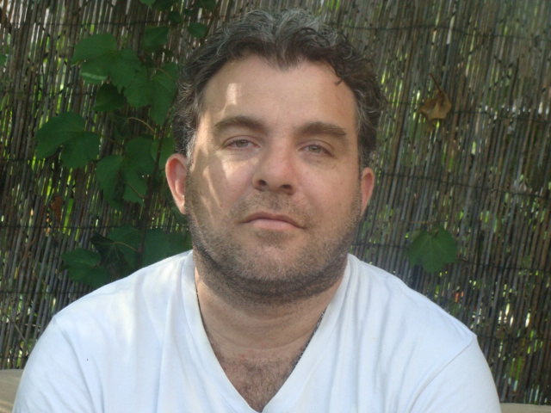 Argentine cook with twelve years experience in the hospitality
- industry.
- Experience in a wide array of regional cuisine.
- Experience in food handling and production at restaurant level, as well as charcuterie production as a business owner.
- As a ejecutive chef I have managed a team of up to 15 cooks.
- I have been envolved in food cost allocation using Excel spread sheets.
- I also have experience in menu development, employee management and organization of banquets and other events.

WORK EXPERIENCE
01/11-04/11 chef du cusine Petrossian restaurant,French cusine
182 west 58 st ny,new york
09/09-01-11 Chef Sweetwater restaurant, American bistro
105 N6 st Williamsburg Brooklyn NY

01/09 Chef Green Canteen, Mediterranean food
106 N6 th st Williamsburg Brooklyn NY –Close-

04/06-01/09 Sous-Chef Brownstein’s, Café, Catering & Classes
557 W 23rd street, New York 10011, NY
09/06-01/07 School Training L’Ecole, New York, NY
Worked in garde manger, poissonnier, saucier and pastry
stations at the restaurant of The French Culinary Institute,
as part of the curriculum.

03/05-04/06 Sous-Chef Fada, French Food
550 Driggs St, Williamsburg, Brooklyn. United state.

01/04-03/05 Cook Gravy, New American Food
102 Smith St, New York. United state.

04/03 – 01/04 Cook Pasifico, Mexican Food
269 Pasifico St, New York, United State

02/02 – 04/03 sous Chef Village 247, Traditional American Food

247 Smith st, Brooklyn, New York, United State.

02/01 – 02/02 Sous-Chef Sur, Argentinean Steakhouse
232 Smith, Brooklyn, New York, United State.

02/01 – 02/02 Sous-Chef Providence,Mediterranean food
237 Smith st ,Brooklyn,New york,united state.

1999 Line Cook Puerto Sol, Mediterranean Food
Bulnes 2593, Buenos Aires, Argentina

EDUCATION
2006 Grand Diploma in Culinary Arts The French Culinary Institute, New York, NY
Intensive nine month course of
culinary study and 600 hours of
hands on practical training in
classic French cooking
techniques.
2005 Master Class in Cooking The New School Culinary Arts, New York
2000 – 2001 Hospitality Worker Diploma Sindicato Argentino de Gastronomía (SAG)
(Argentine Gastronomy Syndicate)
Buenos Aires, Argentina
CURSOSES TAKEN
2004 Master Class in Italian Cooking The New School Culinary Arts, New York
Introduction to Sushi The New School Culinary Arts, New York

2003 Certificate in Food Protection Department of Health, City of New York

ADDITIONAL INFORMATION
I have travelled through the following countries, exploring their culinary habits: Argentina, US, Spain, France, italy,UK,Portugal, Brasil,Uruguay, Czech Rep, Germany and Austria .

Spanish Speaker, Fluent in English

